**Instruction**

What this package does:

This package contains the windows phone 8 (not 8.1) plug-in for your application that adds unity3d google adMob banner or interstitial ad in your project.

System requirements:

* Version unity3d not higher 5.2.4f1;
* Visual studio community 2015;
* Windows phone 8 SDK.

***Tested on unity3d 5.2.4f1 and Visual studio community 2015!***

**How to add a plug-in:**

1. **Adding prefab on a scene:**

Open the scene at which you want to add advertising. Drag the AdMobWp8.prefab file to the Hierarchy panel.

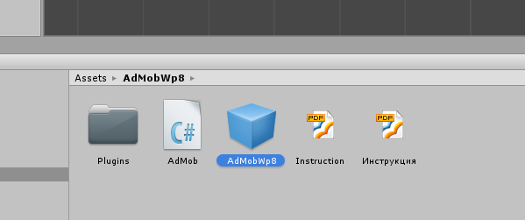

1. **Configuring Admob script:**

Select in Hierarchy AdMob panel object and configure Admob (Script) as you need. Listed below are the controls of the script:

* Banner Enable – banner on/off;
* Unit Id – banner ID. Get it at the <https://apps.admob.com> link. More details how to do this can be found at this link <https://support.google.com/admob/answer/3052638?hl=en>;
* Format – the banner format;
* Horizontal Alignment – the horizontal alignment of the banner;
* Vertical Alignment – the vertical alignment of the banner;
* Interstitial Enable – inclusion of interstitial ad that appears when the current scene is loaded;
* Interstitial Unit Id – an interstitial ad ID;
* Force Testing – test mode for a banner and an interstitial ad.

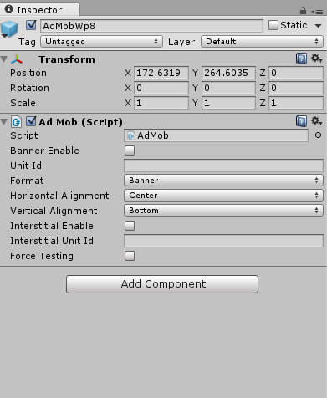

1. **The unity3d project building:**

Open unity3d to build the project. To do this, go to File->Build Settings… or press Ctrl+Shift+B on a keyboard. If the current scene is not added, then add the current scene in the “Scenes In Build” panel, and then click “Add Current” button. Select “Windows Phone 8” platform in the “Platform” panel and click “Switch Platform” button. Click “Build” button to build the “windows phone 8” project for visual studio. Select folder, where visual studio project will be placed.

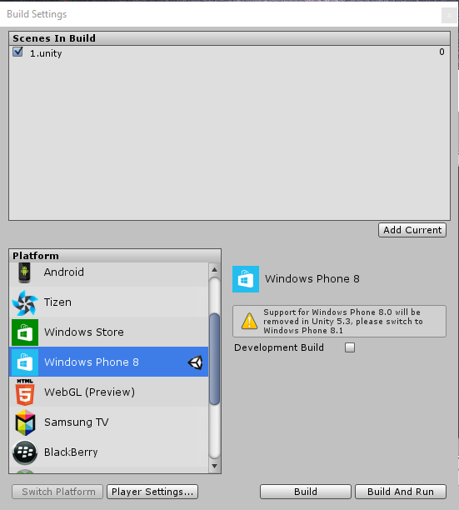

1. **Running project in Visual studio**

Go to the folder that you specified during project assembly in unity3d and run the file * .sln to open solution visual studio. Run the project for execution.

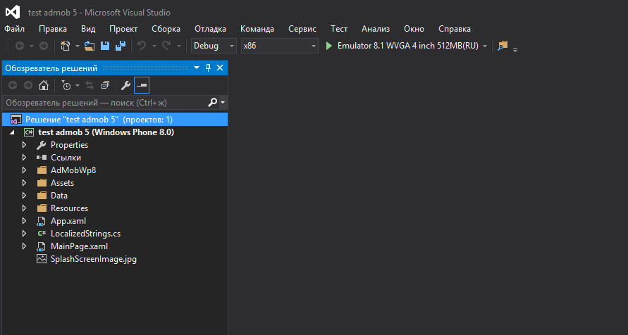

1. **The result of work**

Starting with interstitial loading a scene on the emulator screen.

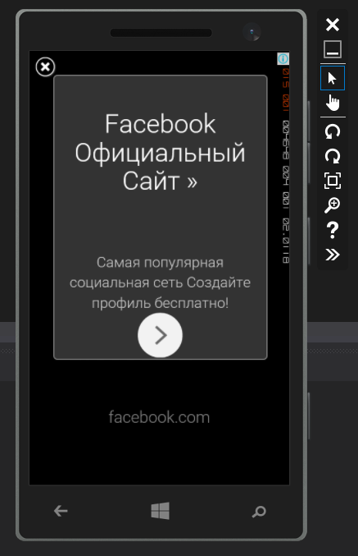

Starting the banner at the bottom of the screen.

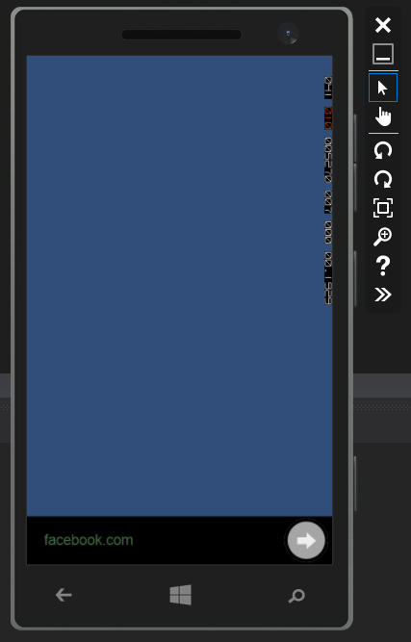

What makes the plug-in when compiling:

* The visual studio project added “POST_BUILD” directive in the project file * .csproj;
* Adding a “ID_CAP_WEBBROWSERCOMPONENT”capability in a Properties/WMAppManifest.xml manifest file;
* Coping a AdMobWp8Plugin.cs file;
* Adding a initialization of plug-in “AdMobWp8.Creator.init(DrawingSurfaceBackground, this.Dispatcher);” in the “MainPage” constructor of “MainPage.xaml.cs” file.
* Coping a GoogleAds.dll library;